**PROJECT SYNOPSIS**

**OF AUTO ANALYSIS AI**

**BACHELOR OF TECHNOLOGY**

**Computer Science and Engineering (Artificial Intelligence & Machine Learning)**

SUBMITTED BY: GUIDEDE BY:

Nitesh, Harshit, Moksh

Roll No: **___________**

Sem: VI



**Dronacharya College Of Engineering Khentawas, Farrukh Nagar (123506), Gurgaon, Haryana**

**Table of Content**

**Auto Analytics AI Bot**

This AI Chatbot will automate the work of analytics by finding the pattern in the data by which it will be very easy to work and analysis.

**Technologies Used:**

* **Technologies:**
* NLP, Machine Learning, Deep Learning, LLM, APIs
* **Backend**
  + - Python, & their libraries
    - MySQL, MS SQL
* **Database**
* PostgreSQL, MySQL, MS SQL, Documents
* **Version Control**
* Github
* **IDE USED**
* VS code, Jupyter notebook

**Overview:**

The project focuses on leveraging data collection and analysis to identify computer automation opportunities. Key data, including service task data and application utilization data, is systematically gathered and analyzed to discern utilization patterns. Through this analysis, the project automatically generates recommendations for automation solutions from a variety of candidates. These recommendations aim to optimize identified computer automation opportunities, streamlining processes and enhancing efficiency within the identified system. By harnessing data-driven insights, the project seeks to advance automation capabilities and drive operational excellence.

**Goals/Objectives:**

* Our main goal is to make analysis automation by finding the patterns in the dataset.
* Identify automation opportunities by utilize data collection and analysis techniques to identify potential areas within the system where automation can enhance.
* Generate automation recommendations by developing algorithms or methodologies to automatically generate recommendations for automation solutions based on patterns.
* Enhance scalability by designing automation solutions that can scale seamlessly to handle large volumes of data as the analysis needs grow.
* This AI will make analysis very easy and learning will be very easy

**Features:**

* **Chatbot:** A user can interact with an AI bot by which it will be very easy to understand the task and the patterns in the data.
* **Database:** A user can bring its own database and connect it with our AI and by providing this data it will find the pattens and find the answer.
* **Chat With SQL:** By using this AI, we can chat out database like SQL it will produce SQL query for you by which we can easily access the data from the database.
* **Analysis:**  By just giving dataset it will be trained on that dataset and make analysis for you. You just need to ask some of the question from this and it will make charts and needed information for you.
* **NLP:** By using natural language processing capabilities, we can interact with AI in Natural language like English.
* **LLM:** We will implement in LLM (Large Language Model) by which it will interact will any kind of data like in document form or any other type of data.
* **Training:** Question=”What is the average age of our customers?”

( Generated query : SQL=”SELECT AVG(age) FROM customers”)

**Methodology/Planning of work:**

Planning is to first of all make the AI model and will me trained on the dataset then integrate it with LLM for natural language processing.

**Facilities required for proposed work:**

VS Code, MySQL, PostgreSQL, Jupyter Notebook

Python

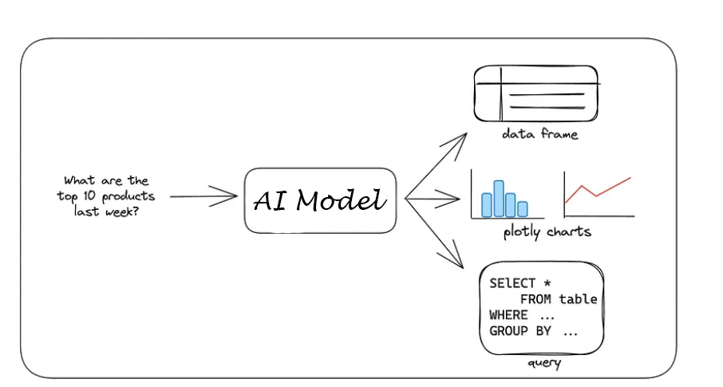

**Reference:**

<https://github.com/sqlchat/sqlchat>

<https://github.com/easy-tensorflow/easy-tensorflow>

<https://github.com/stellargraph/stellargraph>

<https://github.com/neo4j/graph-data-science>